**General Path Loss Model:**

Function for Free Space:

function PL=PL_free(fc,d,Gt,Gr)

% Free space path loss model

% Inputs-----> fc: carrier frequency[Hz] (1.5 GHz)

% d: Distance between base station and mobile station[m] (1km)

% Gt/Gr: Transmitter/Receiver gain

% Outputs----> PL: Path loss[dB]

lamda= 3e8/fc;

tmp= lamda./(4*pi*d);

% if nargin>2

% tmp=tmp*sqrt(Gt);

% end

% if nargin>3

% tmp=tmp*sqrt(Gr);

% end

%PL=-20*log10(tmp); % Equation(1.3)

PL=-10*log10(Gt*Gr)-20*log10(lamda)+20*log10(4*pi)+20*log10(d);

Function for Log-distance and Log-normal:

function PL=PL_logdist_or_norm(fc,d,d0,n,sigma)

% Log-distance or Log-normal shadowing path loss model

% Inputs-----> fc: carrier frequency[Hz] (1.5 GHz)

% d: Distance between base station and mobile station[m] (1km)

% d0: Reference distance[m] (1km)

% n: Path loss exponent (n=2 for free space)

% sigma: Variance[dB]

lamda=3e8/fc;

PL=-20*log10(lamda/(4*pi*d0))+10*n*log10(d/d0); % Equation(1.4)

if nargin>4

PL=PL+sigma*randn(size(d)); % Equation(1.5)

end

Main code:

clear;

clf;

fc = 1.5e9;

d0 = 100;

sigma = 3;

distance = (1:2:31).^2;

Gt = [1 1 0.5];

Gr = [1 0.5 0.5];

Exp = [2 3 6];

for k = 1:3

y_Free(k,:) = PL_free(fc, distance, Gt(k), Gr(k));

y_logdist(k,:) = PL_logdist_or_norm(fc, distance, d0, Exp(k),sigma);

y_lognorm(k,:) = PL_logdist_or_norm(fc, distance, d0, Exp(1), sigma);

end

subplot(131);

semilogx(distance, y_Free(1,:), 'k-o', distance, y_Free(2,:), 'k-^', distance, y_Free(3,:), 'k-s');

grid on;

axis([1 1000 40 110]);

title(['Free Path-loss Model, f_c=', num2str(fc/1e6), 'MHz']);

xlabel('Distance[m]');

ylabel('Path loss[dB]');

legend('G_t=1,G_r=1', 'G_t=1,G_r=0.5', 'G_t=0.5,G_r=0.5');

subplot(132);

semilogx(distance, y_logdist(1,:), 'k-o', distance, y_logdist(2,:), 'k-^', distance, y_logdist(3,:), 'k-s');

grid on;

axis([1 1000 40 110]);

title(['Log-distance Path-loss Model, f_c=', num2str(fc/1e6), 'MHz']);

xlabel('Distance[m]');

ylabel('Path loss[dB]');

legend('n=2', 'n=3', 'n=6');

subplot(133);

semilogx(distance, y_lognorm(1,:), 'k-o', distance, y_lognorm(2,:), 'k-^', distance, y_lognorm(3,:), 'k-s');

grid on;

axis([1 1000 40 110]);

legend('path 1', 'path 2', 'path 3');

title(['Log-normal Path-loss Model, f_c=', num2str(fc/1e6), 'MHz, \sigma=', num2str(sigma), 'dB, n=2']);

xlabel('Distance[m]');

ylabel('Path loss[dB]');

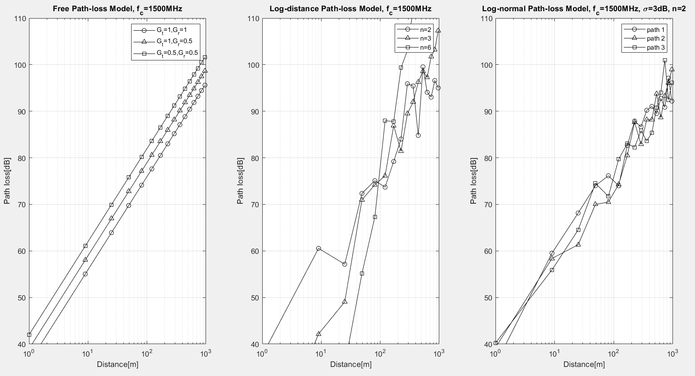

**Okumura/Hata Model:**

Function for PL_Hata:  
function PL=PL_Hata(fc,d,htx,hrx,EType)

% input: fc--> Carrier frequency

% d--> Distance between base station and mobile station

% htx--> Height of transmitter

% hrx--> Height of receiver

% EType--> Environment type (urban, suburban, open)

% Output: PL--> Path loss [dB]

if nargin<5

EType='URBAN';

end

fc=fc/(1e6);

if fc>=150 && fc<=200

C_Rx= 8.29*(log10(1.54*hrx))^2-1.1;

elseif fc>200

C_Rx= 3.2*(log10(11.75*hrx))^2-4.97; % Equation (1.9)

else

C_Rx= 0.8+(1.11*log10(fc)-0.7)*hrx-1.56*log10(fc); % Equation (1.8)

end

PL= 69.55+26.16*log10(fc)-13.82*log10(htx)-C_Rx+(44.9-6.55*log10(htx))*log10(d/1000); % Equation (1.7)

EType= upper(EType);

if EType(1)=='S'

PL=PL-2*(log10(fc/28))^2-5.4; % Equation (1.10)

elseif EType(1)=='O'

PL=PL+(18.33-4.78*log10(fc))*log10(fc)-40.97; % Equation (1.11)

end

Main Code:

% plot_PL_Hata.m

clc;

clear;

fc=1.5e9;

htx=30;

hrx=2;

distance=(1:2:31).^2;

y_urban= PL_Hata(fc,distance,htx,hrx,'urban');

y_suburban= PL_Hata(fc,distance,htx,hrx,'suburban');

y_open= PL_Hata(fc,distance,htx,hrx,'open');

% semilogx(distance,y_urban,'k-s',distance,y_suburban,'k-o',distance,y_open,'k-^')

% title(['Hata PL model, f_c=',num2str(fc/1e6),'MHz'])

% xlabel('Distance[m]'),ylabel('Path loss[dB]')

% legend('urban','suburban','open area',2), grid on, axis([1 1000 40 110])

semilogx(distance, y_urban, 'k-s', distance, y_suburban, 'k-o', distance, y_open, 'k-^')

title(['Hata PL model, f_c=', num2str(fc/1e6), ' MHz'])

xlabel('Distance [m]')

ylabel('Path loss [dB]')

legend('urban', 'suburban', 'open area', 'Location', 'best')

grid on

axis([1 1000 40 110])

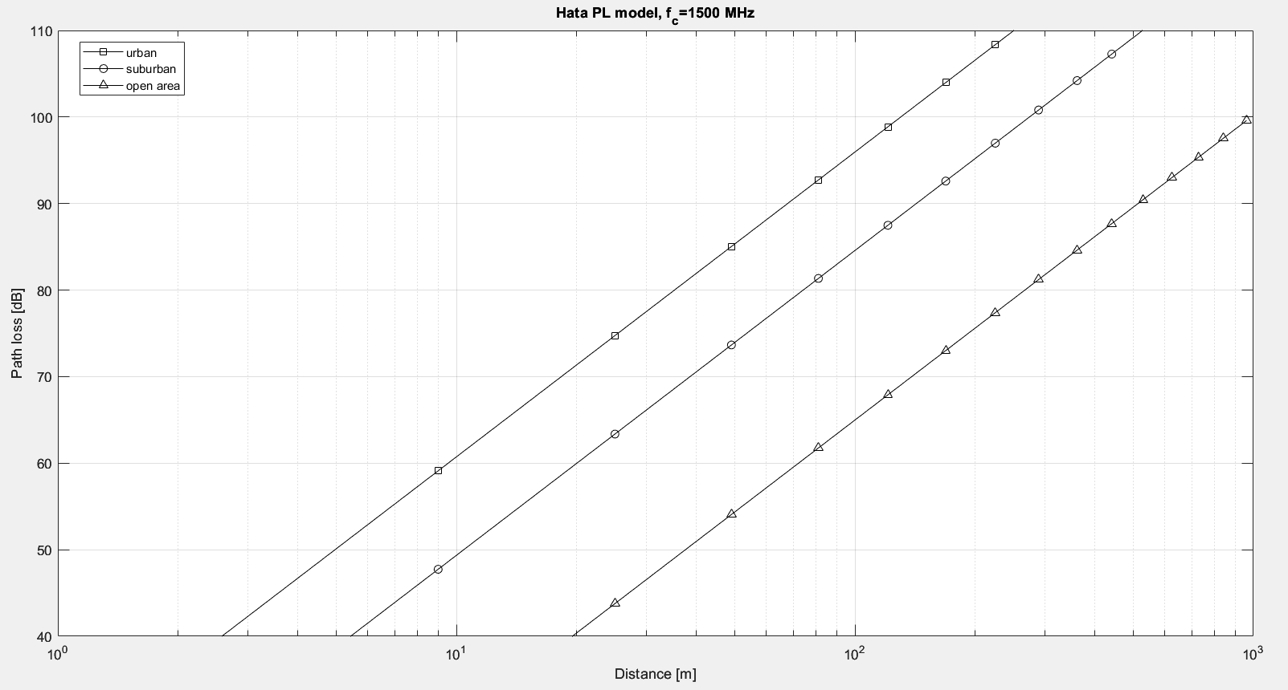

**IEEE 802.16d Model:**

**Function:**

% IEEE 802.16

function PL=PL_IEEE80216d(fc,d,type,htx,hrx,corr_fact,mod)

% IEEE 802.16d model

% inputs---

% fc --> carrier frequency

% d ---> distance between base and terminal

% type-> A,B,C

% htx -> height of transmitter

% hrx -> height of receiver

% corr_fact: if shadowing exists, set to "ATnT' or 'Okumura', or 'no

% mod: set to 'mod' to obtain modified IEEE 802.16d model

% this says if a modified version of this model is used or not

% outputs---

% PL: path loss [dB]

Mod='UNMOD';

if nargin>6

Mod=upper(mod);

end

if nargin==6 && corr_fact(1)=='m'

Mod='MOD';

corr_fact='NO';

elseif nargin<6

corr_fact='NO';

if nargin==5 && hrx(1)=='m'

Mod='MOD';

hrx=2;

elseif nargin<5

hrx=2;

if nargin==4 && htx(1)=='m'

Mod='MOD';

htx=30;

elseif nargin<4

htx=30;

if nargin==3 && type(1)=='m'

Mod='MOD';

type='A';

elseif nargin<3

type='A';

end

end

end

end

d0=100;

Type=upper(type);

if Type~='A' && Type~='B' && Type~='C'

disp('Error: The selected type is not supported');

return;

end

switch upper(corr_fact)

case 'ATNT'

PLf=6*log10(fc/2e9); % Cf

PLh=-10.8*log10(hrx/2); % Crx

case 'OKUMURA'

PLf=6*log10(fc/2e9);

if hrx<=3

PLh=-10*log10(hrx/3);

else

PLh=-20*log10(hrx/3);

end

case 'NO'

PLf=0;

PLh=0;

end

if Type=='A'

a=4.6;

b=0.0075;

c=12.6;

elseif Type=='B'

a=4;

b=0.0065;

c=17.1;

else

a=3.6;

b=0.005;

c=20

end

lamda=3e8/fc;

gamma=a-b*htx+c/htx;

d0_pr=d0;

if Mod(1)=='M'

d0_pr=d0*10^(-(PLf+PLh)/(10*gamma));

end

A=20*log10(4*pi*d0_pr/lamda)+PLf+PLh;

for k=1:length(d)

if d(k)>d0_pr

PL(k)=A+10*gamma*log10(d(k)/d0);

else

PL(k)=20*log10(4*pi*d(k)/lamda);

end

end

**Main Code:**

% plot_PL_IEEE80216d.m

clear, clf, clc

fc=2e9; htx=[30 30]; hrx=[2 10]; distance=[1:1000];

for k=1:2

y_IEEE16d(k,:)=PL_IEEE80216d(fc,distance,'A',htx(k),hrx(k),'atnt');

y_MIEEE16d(k,:)=PL_IEEE80216d(fc,distance,'A',htx(k),hrx(k),'atnt', 'mod');

end

subplot(121), semilogx(distance,y_IEEE16d(1,:),'k:','linewidth',1.5)

hold on, semilogx(distance,y_IEEE16d(2,:),'k-','linewidth',1.5)

grid on, axis([1 1000 10 150])

title(['IEEE 802.16d Path-loss Model, f_c=',num2str(fc/1e6),'MHz'])

xlabel('Distance[m]'), ylabel('Pathloss[dB]')

legend('h_{Tx}=30m, h_{Rx}=2m','h_{Tx}=30m, h_{Rx}=10m','Location','southeast')

subplot(122), semilogx(distance,y_MIEEE16d(1,:),'k:','linewidth',1.5)

hold on, semilogx(distance,y_MIEEE16d(2,:),'k-','linewidth',1.5)

grid on, axis([1 1000 10 150])

title(['Modified IEEE 802.16d Path-loss Model, f_c=', num2str(fc/1e6), 'MHz'])

xlabel('Distance[m]'), ylabel('Pathloss[dB]')

legend('h_{Tx}=30m, h_{Rx}=2m','h_{Tx}=30m, h_{Rx}=10m','Location','southeast')

